- Bluebook Page85 November 2018 variant two examination:

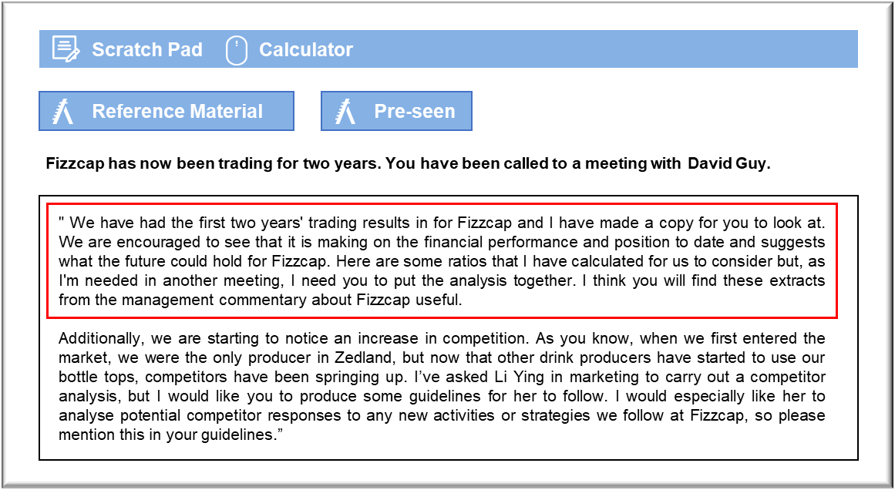
MANAGEMENT CASE STUDY NOVEMBER 2018 EXAM ANSWERS

Variant2 Task4
These answers have been provided by CIMA for information purposes only. The answers created are indicative of a response that could be given by a good candidate. They are not to be considered exhaustive, and other appropriate relevant responses would receive credit.

CIMA will not accept challenges to these answers on the basis of academic judgement.

Performance
Fizzcap has been trading for two years and its revenue has increased by 44.4%. This is
impressive for a business over its first two years.
Revenue growth may come from increases in sales volume and/or price. The extracts
suggest that the sales prices have remained stable and so the increase is down to
higher sales volumes being made. The increase in market share supports this too. The
increase in revenues would improve further with a higher market share.
The gross profit margin has reduced slightly over the two years despite the operating
profit margin increasing slightly. Sales prices have remained stable so the reduction in
the gross profit margin is due to an increase in the cost of sales. The raw materials are
bought from an overseas supplier and the price will change if there are fluctuations in
the exchange rate between Z$ and D$. The figures suggest that either the price of
metal has increased or that the exchange rate has moved against Fizzcap. As the
business grows, there will be economies of scale and Fizzcap's purchasing director
should negotiate discounts for buying in bulk. This will reduce the price per unit and
should improve margins.
The fact that the operating profit has increased despite the reduction in gross margin is
positive. The main reason for this difference seems to be that in year 1 an external
consultant was used whereas in year 2 it may be that the staff took over the role they
were performing when the consultants’ contracts were not renewed. This may have
given rise to cost savings and therefore increased the operating profit. Further cost
savings and efficiencies in the future should improve this ratio further, especially if
improvements can be made to the gross profit margin.
The return on capital employed (ROCE) has improved this year, lightly. This will be due
in part to the increase in the operating profit from the savings made with external
consultants. In addition, as the machinery and intangibles get older, their carrying value
reduces through depreciation and amortisation. This in turn, reduces the capital
employed and so ROCE will increase. When the new machines are bought the ratio
may worsen unless there is a significant improvement in operating profit.
Gearing ratio has reduced this year. This tells us that the level of debt compared to
equity has reduced. This could be because the level of equity is increasing with more
profits each year and/or some of the debt has been paid back. As the gearing level
reduces this makes Fizzcap look more attractive to future investors. TipTops and
Grapple will not want to issue more shares as they will lose control of Fizzcap but there
may be a need for more debt to help with the investment of replacement machinery.
The improvement in the interest cover suggests that either some debt has been repaid
or the interest rates have reduced. This could also be due to the increase in operating
profit levels. This is a positive sign but if interest rates rise or if new debt is issued to
acquire more machinery, this may fall again. Fizzcap will need to make sure that the
levels do not fall enough for the banks to raise concerns and recall the loans from
breaches of debt covenants.

Competitor Analysis
It is important to analyse competitors in order to understand how our market place is
adapting and what we need to do to stay ahead of the game. The emergence of
competitors may lead to lower prices or a loss of customers, although Grapple remains
the main customer of Fizzcap and there is no danger of that relationship stopping.
When carrying out competitor analysis, we can categorise the competitors according to
their level (brand, industry, generic or form) and their likely responses (laid-back,
selective, tiger, stochastic).
Considering the level, we should probably be most concerned about industry and form
competitors. Industry competitors are those which are competing with the same product,
regardless of the size or structure of their organisation. Form competitors, as these are
the ones that satisfy the same need with a similar, but different, product. These would
be the producers of traditional bottle tops for example.
With regards to responses, there are four types of competitor we may expect to see:
• Laid-back – would not respond to our moves
• Selective – only reacts in certain markets or to certain strategies. With these, we
would need to understand which strategies would lead to a response.
• Tiger – these are aggressive competitors who will always act in that manner. We
need to identify these and understand our advantages over them.
• Stochastic – These are unpredictable. We still need to know who they are, but
there is probably little point in attempting to predict their responses.
When carrying out competitor analysis we should remember that some methods are
unlikely to obtain suitable results with this product, given that it is only a part of the
packaging for a drink, rather than the drink itself. Asking the end customer about
different bottle tops used would probably be futile; they would have no choice but to
accept the top which comes with the chosen drink.
We could use the following research methods:
1) Buy some of our competitors' products and reverse engineer to determine likely costs
of production as well as assessing the product against our own.
2) Use available sources to determine key measures such as profitability, revenue (and
hence market share) and growth. We know that our revenue grew 44% year on year;
we could see whether any other competitors were growing as quickly.
3) Industry publications, such as Drinks Manufacturing Monthly, will show up to date
articles on competitor activity.
One problem with all of these methods is that they are unlikely to provide valuable
information with regards to competitor responses. It may be that the only way to
determine this is to try out some incremental changes and note the responses. Another
way could be to examine past information about them in any previous markets.

